**OUR STORY**

Kayla was a happy and healthy 18 month old girl when she unexpectedly passed away.  Kayla was found unresponsive after taking a short afternoon nap.  The cause of Kayla's death continues to be unknown however it is often classified as Sudden Unexpected Death in Childhood (SUDC).

**​**

Kayla's Cause is a non-profit organization established after the unexpected death of 18 month old Kayla Rose Caron. The mission of Kayla's Cause is to  increase awareness and support individuals, communities and organizations that are impacted by Sudden Unexplained Death in Childhood (SUDC)

For more information on Kayla’s Cause visit [**https://www.kaylascause.org/**](https://www.kaylascause.org/)

For more information on SUDC visit <https://sudc.org/>

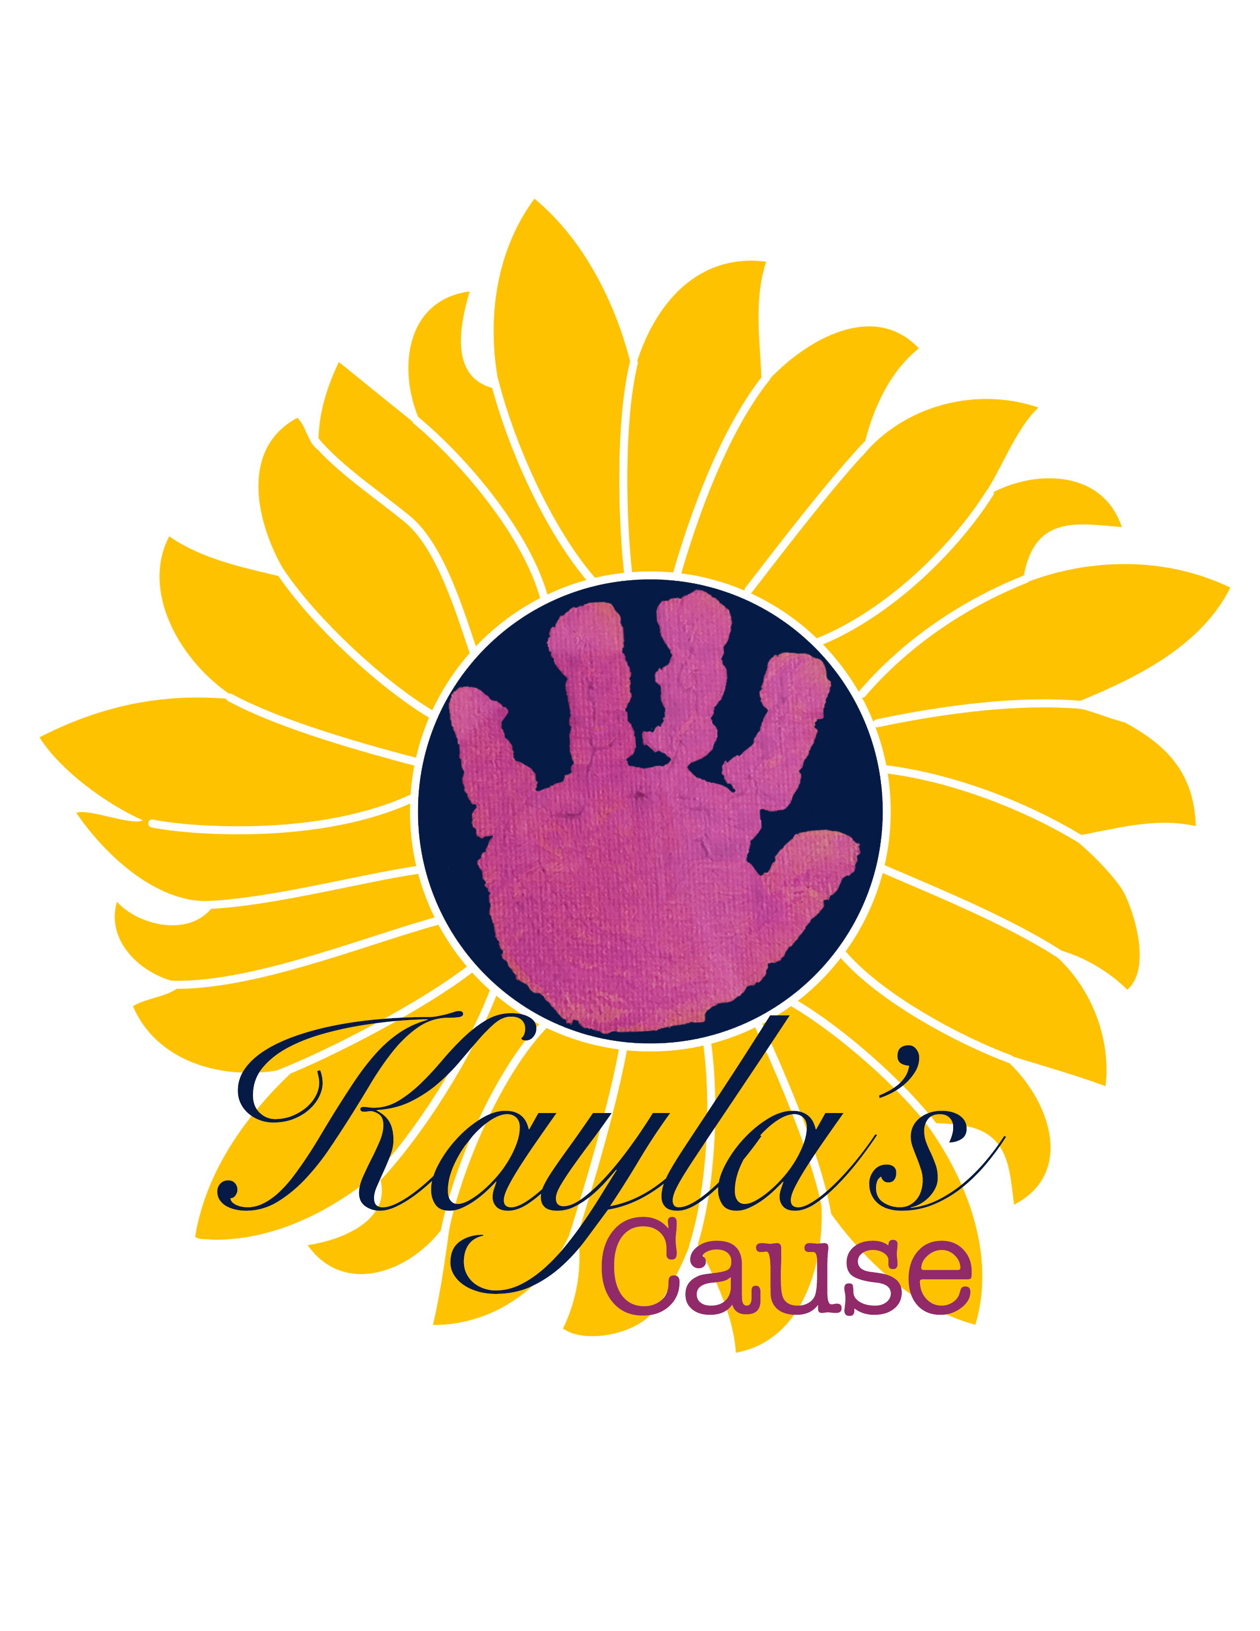

# **Random Act of Kindness in Memory of Kayla Rose Caron 4/13/16-10/10/17 Kaylascause.org**

**SUDC AWARENESS MONTH**

